  - Author and Illustrator, Stephanie L Schulz will be here at Meadowbrook Thursday Feb 28th to sign your copies of her newest book, Blueberry Hill!
Pre-order sale price  $15 each  Ms. Schulz will also have her two other books available for purchase on Thursday night!  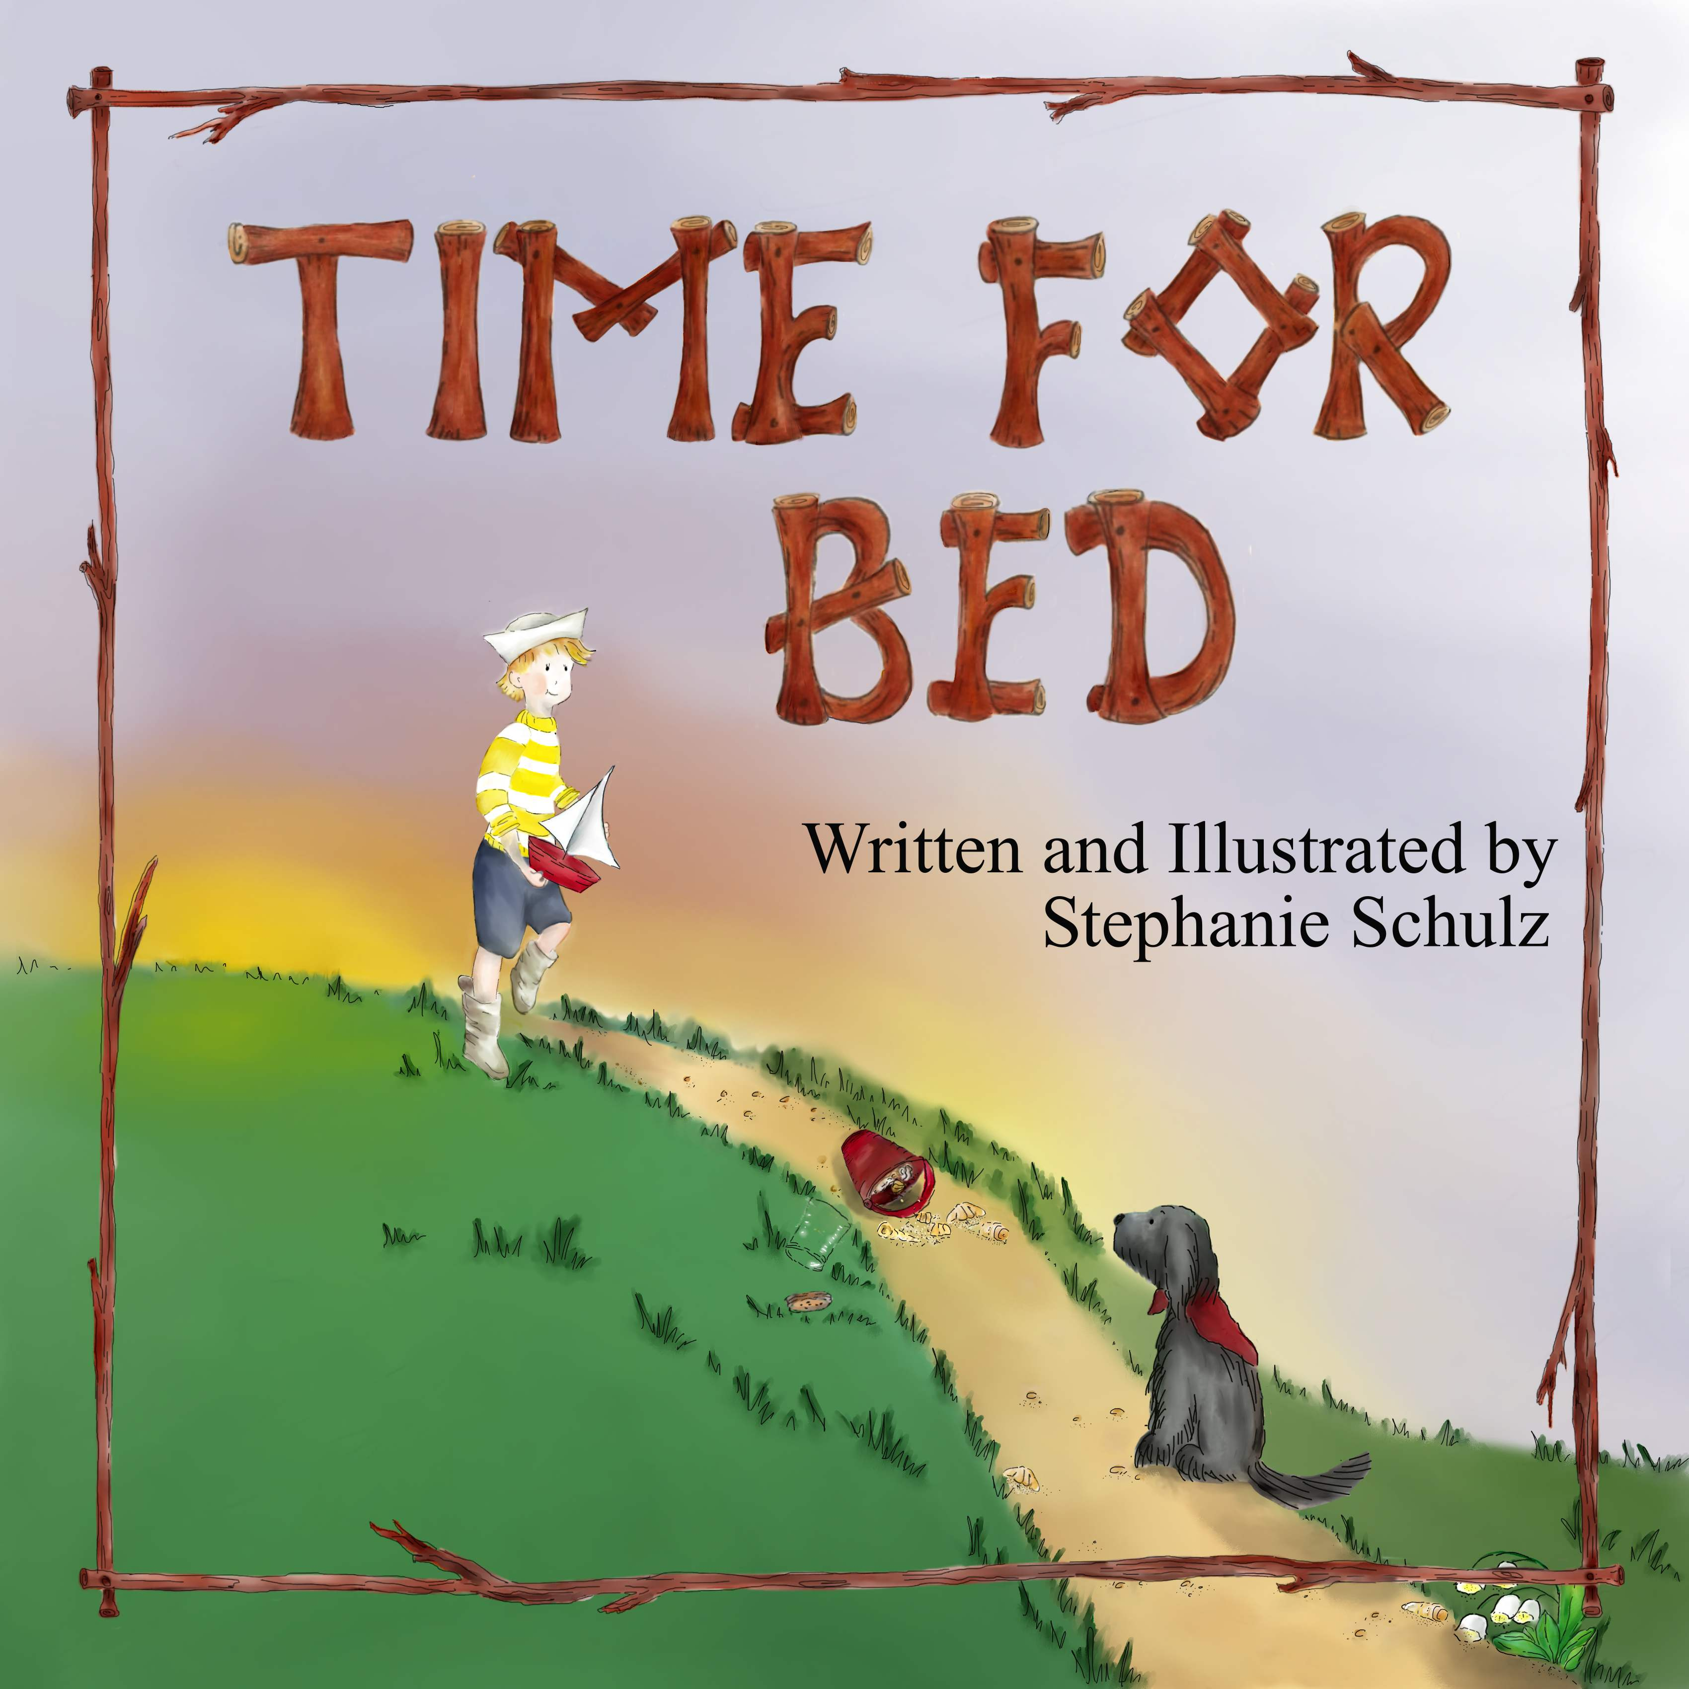  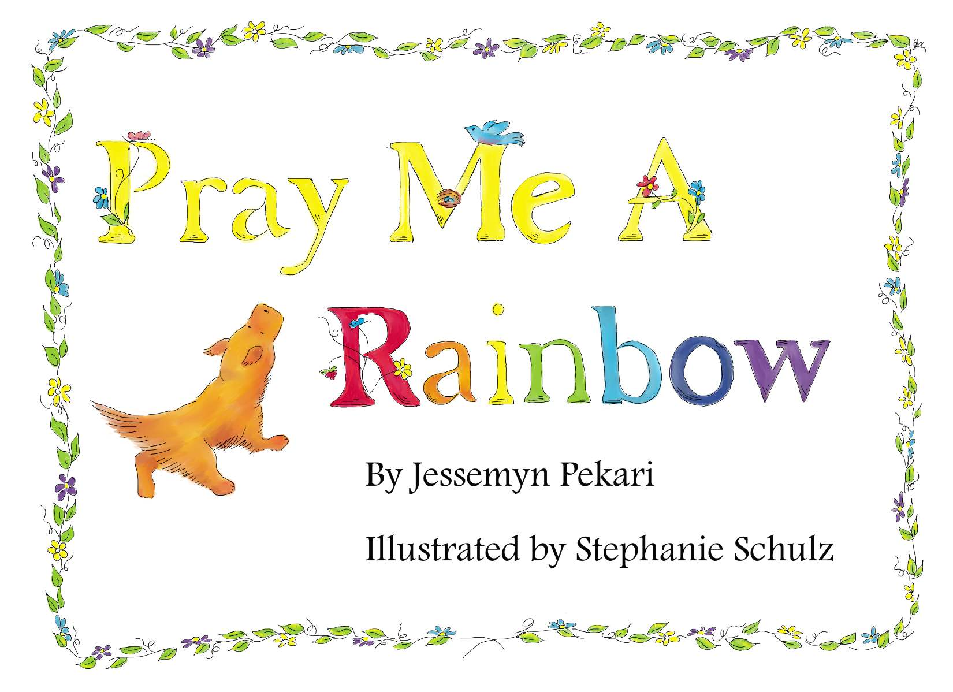 | 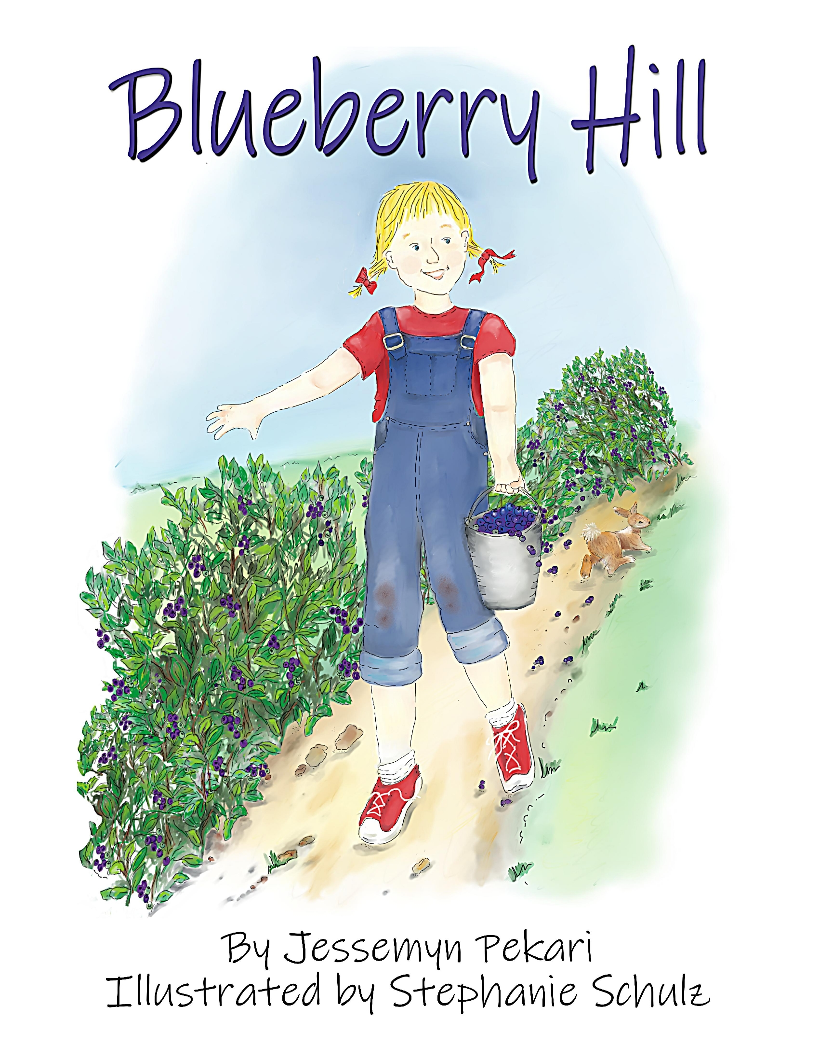

Childs Name____________________________________________________________________________________
Teacher/Grade/Room # __________________________________________________________

I would like ______ copies of Blueberry Hill @ $15 each Total $_______
I would like ______ copies of Time for Bed @ $15 each Total $_______
I would like ______ copies of Pray Me A Rainbow @ $15 each Total $_______

Make check out to: Stephanie L Schulz Return to Meadowbrook Elementary School
ALL book orders are due by Friday March 1, 2019

34 JB Ivey Lane | Lake Junaluska, NC | 850-445-4375 | pspresspublications.com

